# Steps to build and run the application

Prerequisites

1. Install either npm or node js latest version
2. Install Angular CLI using the command below

* npm install -g @angular/cli

**Build and Run the Application**

1. Clone or download the code from github url and unzip

<https://github.com/arifshaiktechstack/ProductDetailsAngular>

1. Open the command promt and change the folder where code is copied or extracted.
2. Build the dependencies using the command below.This step may take upto 4 mins

* npm install

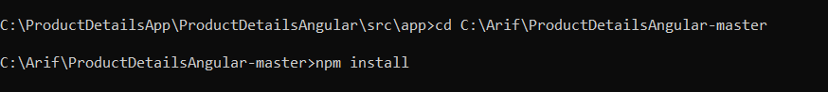

1. Run the application using the command below.

* ng serve

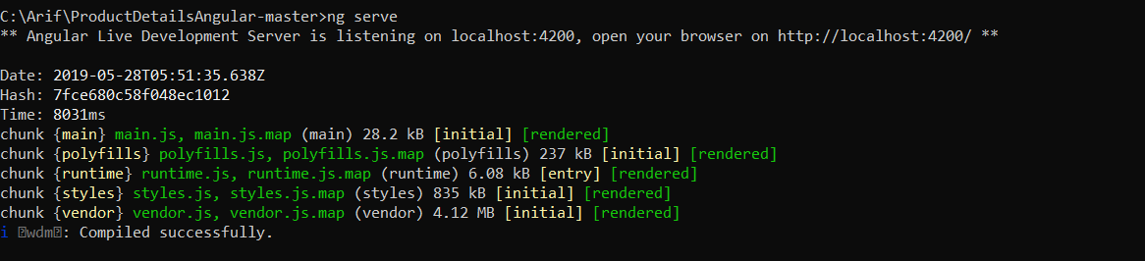

1. Once successfully build open the browser and enter url <http://localhost:4200/>

**Important Note**

The products URL provided <https://www.westelm.com/services/catalog/v4/category/shop/new/all-new/index.json> gives error “Access-Control-Allow-Origin” which means the url can not be invoked from another domain in this case localhost.

To get rid of this error, we need a server side change to allow cross origin calls.

Hence I copied the json into assent folder of the application in the below path.

**SourceCodeFolder\src\assets**

In case we have to test with the original Url if the above error is resolved, then make the below change

Open file **SourceCodeFolder**\src\app\services\products.service.ts and comment line 15 and uncomment line 14

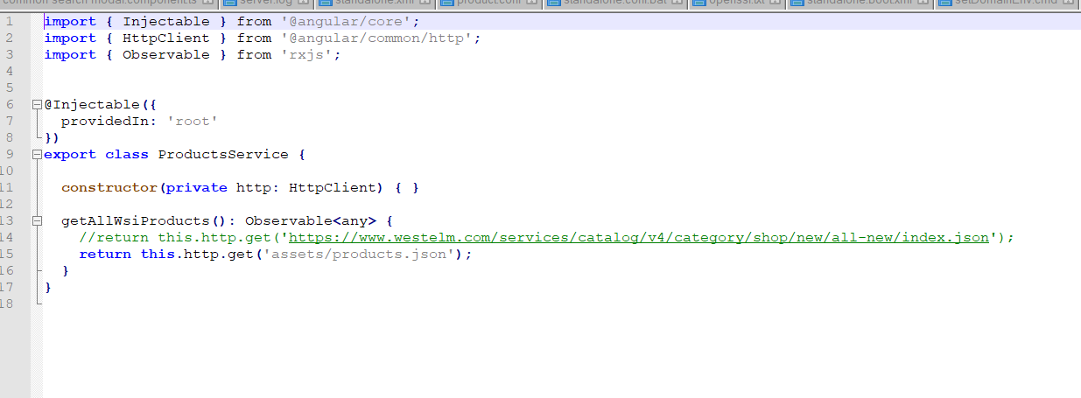

**Screenshots**

Home page

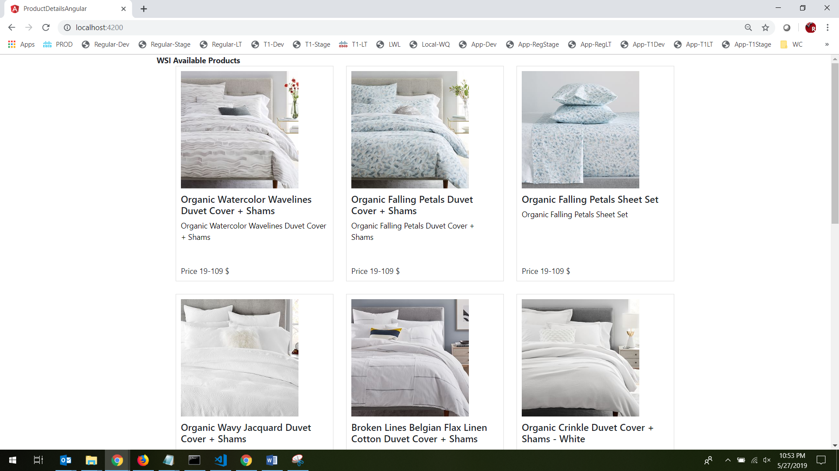

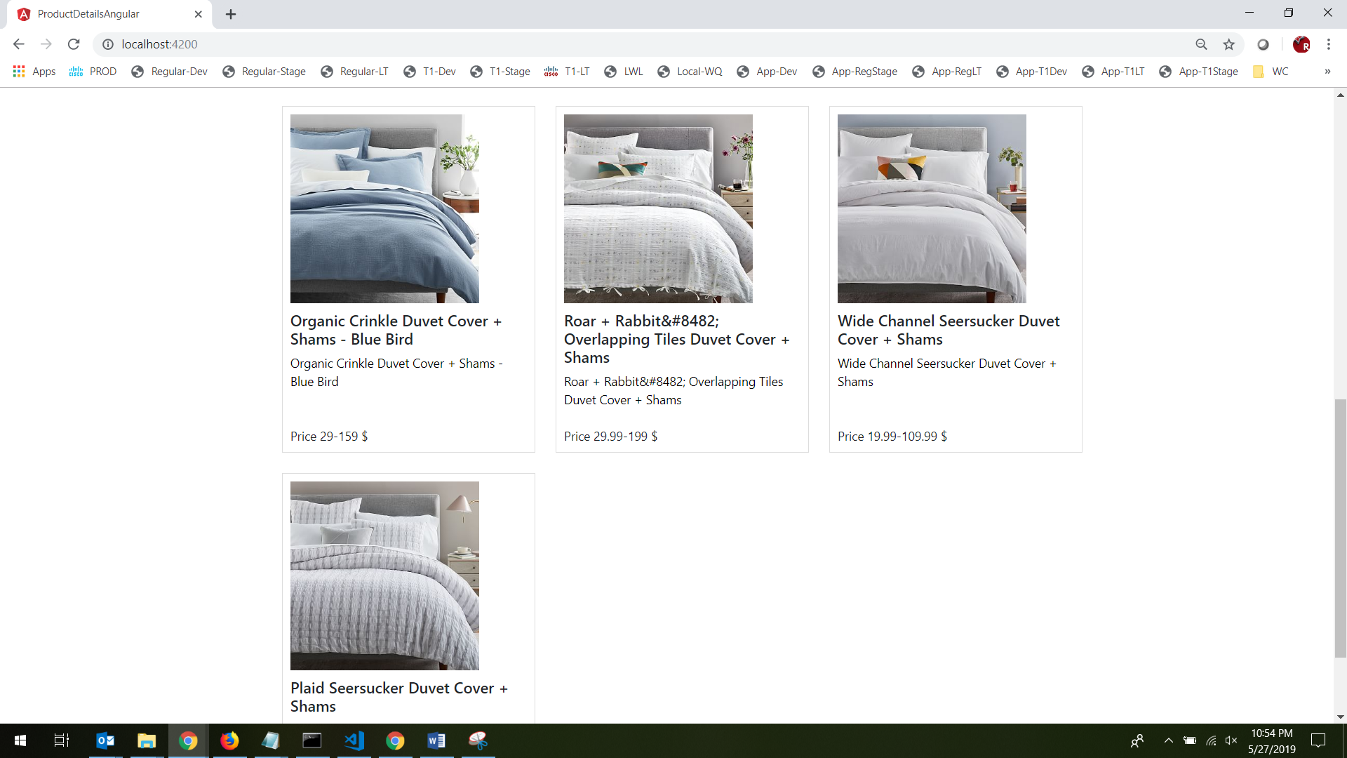

Click on the image to open couresal.

